DCA Review: Meteorology and Oceanography

1. Which process adds water to the atmosphere?
a. condensation
b. runoff
c. precipitation
d. evaporation
2. Which process returns water to Earth’s surface
a. condensation
b. runoff
b
d. evaporation

3. Put the four types of water in order from least to most dense. (cold fresh, cold salt, warm fresh, warm salt)

warm fresh<cold fresh<warm salt<cold sat

4. What two factors affect the surface temperature of seawater?
Depth and latitude

5. What is the most abundant salt in the ocean? Sodium chloride

6. What processes increases the salinity of the oceans?
Evaporation, sea ice forming

7. ______warm________ currents move towards the poles and _______cold_______ currents move towards the equation.

8. What is an upwelling?

Cold, nutrient rich water moves up by the shores

9. How does the atmosphere move energy from place to place?
Heat energy is moved by convection currents in the ocean and with wind.

10. What type of heat transfer is the sun’s energy being transferred to Earth?

radiation
11. Which place has the warmer ocean water? Why?
It is place B because the water is coming from the equator.

12. Where is the only ocean current to completely circle the Earth?
Antarctica

13. What is the ultimate source of wind?
Solar radiation

14. How are air pressure differences generated on Earth?

Difference in heating caused by solar radiation

15. What is albedo? Give an example of low albedo and high albedo.

Reflectance of a surface. Low albedo is asphalt. High albedo is snow.
16. How does cloud cover affect albedo?
Reflects solar radiation during day. Traps radiation at surface level at night.

17. ___________warm_________ air moves towards the poles and ________cold________ air moves towards the equator.

18. Label the major wind belts on the globe below.

Polar Easterlies at top, then westerlies in middle, and trade winds by equator.

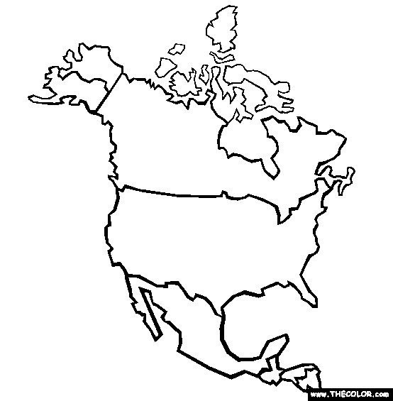
19. Label the air masses in the figure below.

A is continental polar
B is maritime tropical

20. What type of front is shown below? ________________________it is a warm front________________
21. What does the mean for point A’s weather in the next couple of hours?

It will start increasing temperatures

22. Label the climate zone on the global below.

1. is polar
2. is temperate
3. is tropical

23. How does latitude affect climate?

Increasing latitude, decreasing temperatures

24. What type of climate is found on the windward side of a mountain? Leeward side of a mountain?
Windward is cool, wet
Leeward is warm, dry

25. What are the two main greenhouse gases?
Carbon dioxide and water vapor

26. What is global warming?
Warming of Earth’s surface and lower atmosphere due to an increased amount of greenhouse gases in the atmosphere.

