Astronomy DCA Review
1. How did the sun and solar system form?
Cloud of gas and dust rotating and condensing to form sun and solar system

2. Write a statement regarding the diameters of the planets.
Jovian planets have a much larger than terrestrial planets.

3. Write a description of terrestrial planets. Write a description of jovian planets. Include composition and atmosphere.
Terrestrial planets are rocky and have thin atmospheres. Jovian planets are gaseous and have thick atmospheres.

4. What is NOT part of our solar system?
a. Multiple stars
b. Multiple asteroids
c. Multiple comets
d. Multiple planets

5. If astronomers are using a spectroscope to study stars, which two types of data will they gather?
1. composition 2. Direction of motion

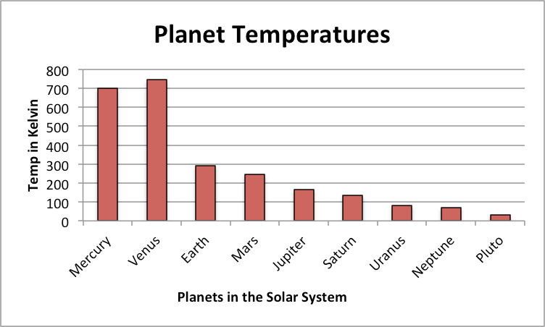

6. What is the highest temperature a jovian planet reaches? What about a terrestrial planet?

~90K for jovian
~750K for terrestrial
7. What does a reflecting telescope use to collect light?
Mirror

8. What does a refracting telescope use to collect light? What is a disadvantage of a refracting telescope?
Lens; chromatic aberration (the image is blurry)

9. What does the color of a star indicate?
Temperature

10. What does a radio telescope look like? Either draw a picture or write a description.
A large satellite that picks up radio waves

11. What is advantage of having a space telescope over other telescopes?
No interference from atmosphere

12. Star A is has a very large red shift while star B has a smaller red shift. What is true about the speeds of stars?
Star A is moving away from earth faster than star B

13. As the star gets further from Earth, what is true about the parallax angle?
The parallax angle gets smaller

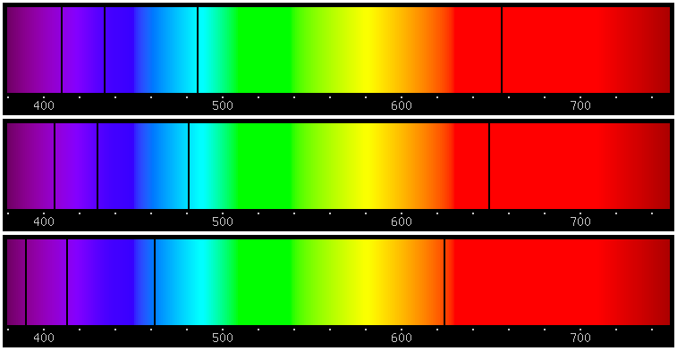
Control
A
B

14. Which direction is Star A moving from Earth? Which direction is star B moving from Earth? Use the control to compare.

Star A is moving away. Star B is moving towards

15. What does a spectra of a star tell an astronomer about a star?
The composition of the star or the direction it’s moving.

16. Why does our Sun have a bright apparent magnitude but a dim absolute magnitude? Think what is the difference between apparent and absolute magnitude.
It has a bright apparent magnitude because it’s close to Earth but a dim absolute magnitude because compared to other stars it’s neither as big nor as bright.

17. What is absolute magnitude? What is apparent magnitude?
Absolute magnitude is the brightness of the star compared to other stars at the same distance. Apparent magnitude is how bright it appears from Earth.

18. What is the longest stage during a star’s life cycle? Main sequence

19. What is the next step in the life cycle of our sun? Red Giant

20. What will eventually happen to all stars regardless of their mass?

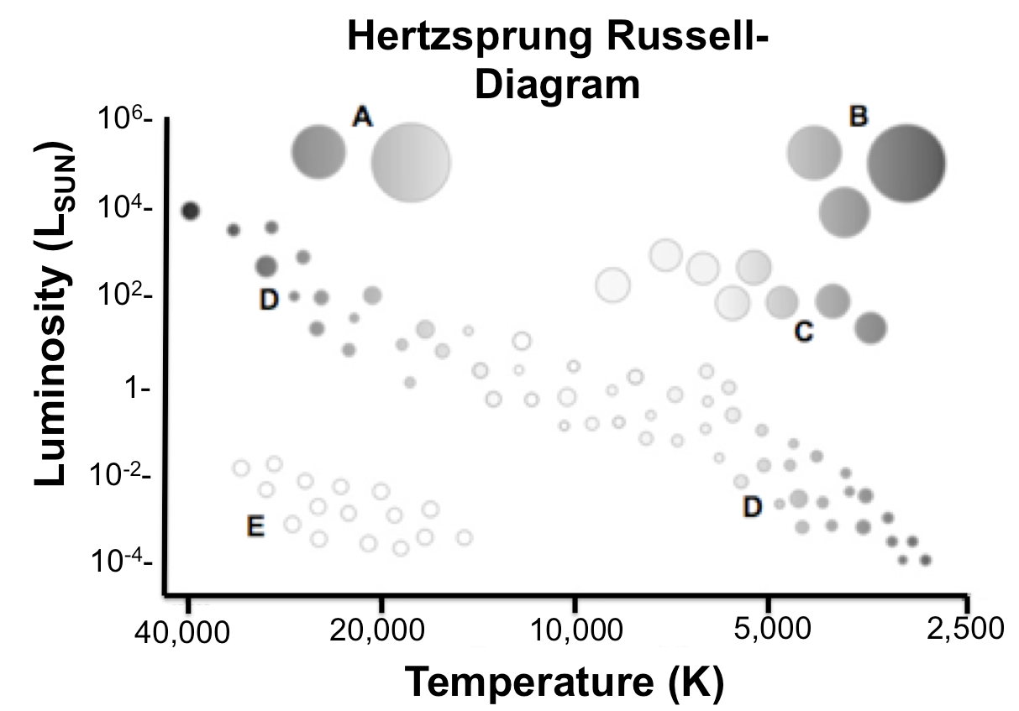
All stars will run out of fuel and die.

21. Which letter correctly identifies where our sun would be found?

D

22. Which letter correctly identifies where a Red Super giant would be found?

B

23. What would be the temperature range over which you would find a white dwarf?
15,000K-40,000 K
24. What is the name of our galaxy?
Milky Way

25. What are the types of galaxies?

Spiral
Irregular
Eliptical

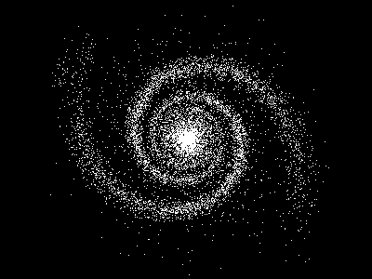

26. Which type of galaxy is shown above?

Spiral

27. What is known about the rate of expansion of the universe?

It is expanding at an increasing rate

28. What device was used to find background cosmic radiation?

Radio telescope

29. What are the three pieces of evidence for the Big Bang Theory?
Cosmic Background Radiation, Red Doppler Shift of distant galaxies, and uniform composition of universe.

